**Compass MED D - Blue MedicareRx (NEJE) - Compass Disenrollment Reason - Processes and References**

General Information

Related Documents

**Description:** This document assists the Blue MedicareRx (NEJE) CCR with locating the correct process or work instructions when a beneficiary has been disenrolled.

| General Information |
| --- |

When researching the reason why a beneficiary has been disenrolled, the CCR will refer to the **Compass** - **Medicare D Landing Page - Disenrollment Reason.**

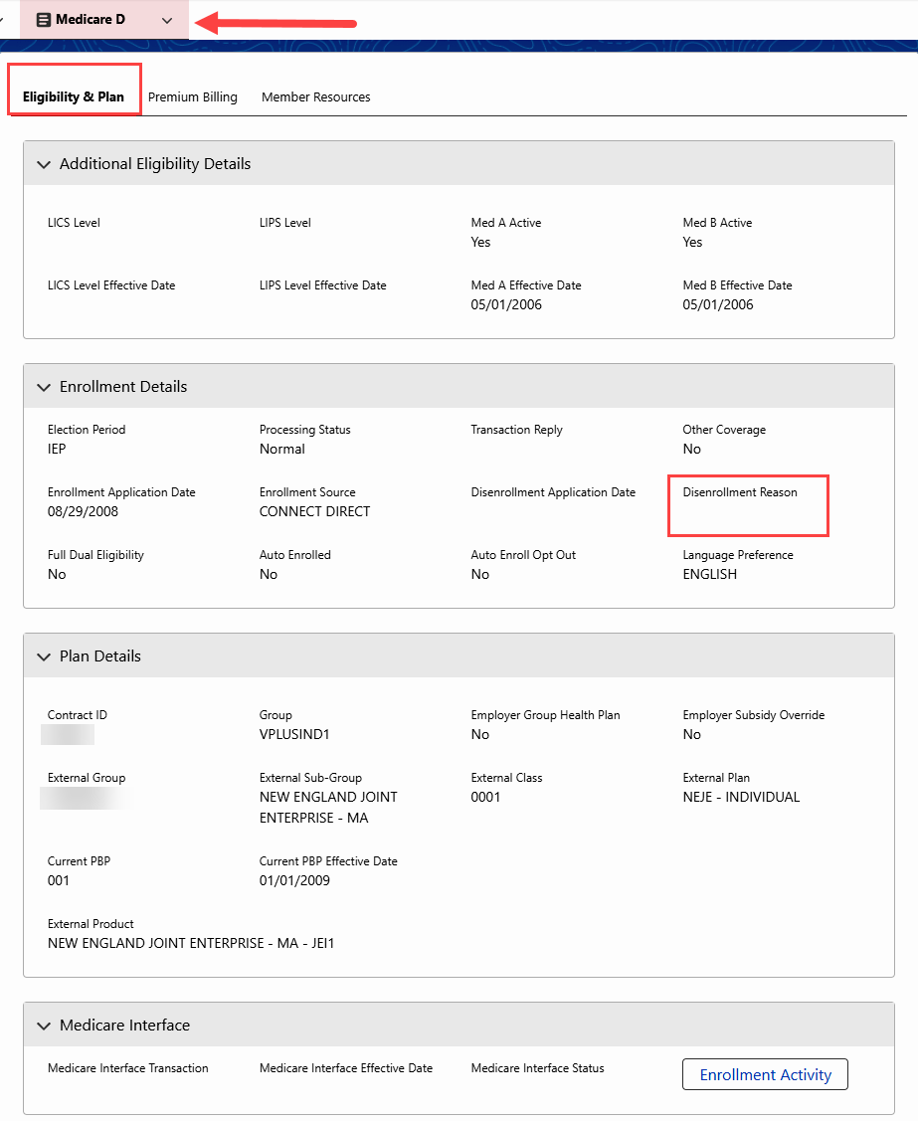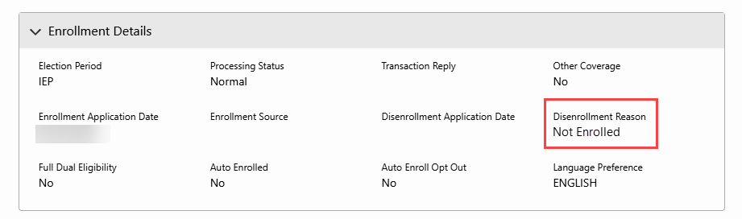

**Example:** Disenrollment Reason Field

The CCR will utilize the chart below to find the correct process or work instruction to reference to resolve the beneficiary’s issue.

**Note:** The CCR should also reference the disenrollment letters in the **Last 12 months of Medicare D Communications** hyperlink in the **Medicare D Quick Actions** panel of the **Medicare D Landing Page** and all previous call notes in the **Member’s Recent Cases panel** in the **Case Details** and **Member Snapshot Landing Page** and the **Medicare D Landing Page - Medicare D Alerts** section.

|  |  |  |  |  |
| --- | --- | --- | --- | --- |
| **Reason** | **Process** | | | **Work Instruction** |
| 1. **OUT OF AREA DISENROLLMENT**   Beneficiary has confirmed a change in residence outside their current service area/region and must be disenrolled, this includes out of the country. | Refer to Work Instruction. | | | [Compass MED D - Address Changes and Out of Area (OOA)](https://thesource.cvshealth.com/nuxeo/thesource/" \l "!/view?docid=a5cf7af0-8a89-45dc-a395-9961dceac183)  [Compass MED D - RxEnroll Care Downtime Procedures - Address Changes and Out of Area (OOA)](https://thesource.cvshealth.com/nuxeo/thesource/#!/view?docid=f7cd8032-f520-448e-b45f-842b4a6cd07d) |
| 1. **INCARCERATED**   The status of an individual who is in the custody of a penal authority and confined to a correctional facility, such as a jail or prison, or a mental health institution as a result of a criminal offense. Such individuals reside outside of the service area for the purposes of Part D plan eligibility, even if the correctional facility is located within the plan’s service area. | Refer to Work Instruction. | | | [Compass MED D - Address Changes and Out of Area (OOA)](https://thesource.cvshealth.com/nuxeo/thesource/" \l "!/view?docid=a5cf7af0-8a89-45dc-a395-9961dceac183)  [Compass MED D - RxEnroll Care Downtime Procedures - Address Changes and Out of Area (OOA)](https://thesource.cvshealth.com/nuxeo/thesource/#!/view?docid=f7cd8032-f520-448e-b45f-842b4a6cd07d)  [Compass MED D - SilverScript and Blue MedicareRx (NEJE) - Resolving Eligibility Issues for Incarcerated or Not Lawfully Present Beneficiaries](https://thesource.cvshealth.com/nuxeo/thesource/" \l "!/view?docid=8824428c-b769-4917-83bf-19549ec6f873) |
| 1. **UNLAWFULLY PRESENT**   The status of an individual who is not lawfully present (not a US citizen). An alien who is lawfully admitted for permanent residence at the time of enrollment or considered lawfully present for the purposes of applying for Social Security benefits.  An individual who is not lawfully present in the Unites States is not eligible for any federal public benefit, including payment of Medicare benefits. | Refer to Work Instruction. | | | [Compass MED D - SilverScript and Blue MedicareRx (NEJE) - Resolving Eligibility Issues for Incarcerated or Not Lawfully Present Beneficiaries](https://thesource.cvshealth.com/nuxeo/thesource/#!/view?docid=8824428c-b769-4917-83bf-19549ec6f873) |
| 1. **LOSS PART D ELIGIBILITY**   Beneficiary has lost entitlement to Medicare. This includes loss of A/B/D. | Refer to Work instruction. | | | [Compass MED D - Blue MedicareRx (NEJE) - Mistaken Disenrollment of a Beneficiary](https://thesource.cvshealth.com/nuxeo/thesource/" \l "!/view?docid=bc09e268-8503-4951-8671-ad5c4eaddfa2) |
| 1. **MEMB DECEASED**   Death of the beneficiary | Refer to Work Instructions.  **Note:** Do **NOT** send a Support Task to notify Enrollment Operations of the beneficiary’s death. | | | [Compass MED D - Deceased Beneficiary](https://thesource.cvshealth.com/nuxeo/thesource/#!/view?docid=03532634-0441-4503-8b66-d19f9eec0c32)  [MED D - When to Refer to Social Security (SSA) and Medicare (CMS)](https://thesource.cvshealth.com/nuxeo/thesource/#!/view?docid=c9e294cd-93c4-466f-a6d8-e850070eda25) |
|  |  | | | If an error:  [Compass MED D - Blue MedicareRx (NEJE) - Mistaken Disenrollment of a Beneficiary](https://thesource.cvshealth.com/nuxeo/thesource/#!/view?docid=bc09e268-8503-4951-8671-ad5c4eaddfa2) |
| 1. **IRMAA DISENROLLMENT**   Beneficiary failed to pay Income Related Monthly Adjustment Amount (IRMAA) payments with Part D premium. | Refer to Work Instruction. | | | [Compass MED D - Blue MedicareRx (NEJE) - Process for Good Cause Determinations - For Non-payment of Part D-IRMAA](https://thesource.cvshealth.com/nuxeo/thesource/#!/view?docid=e48b9c43-2be3-4acf-a03c-208a216d6d70) |
| 1. **NON NEJE INV TERM**   **OR**  **INVOLUNT DISENROLL NO PAY PREM**  Beneficiary failed to pay premiums | Refer to Work Instruction. | | | [Compass MED D - Blue MedicareRx (NEJE) - Dunning and Disputes Process](https://thesource.cvshealth.com/nuxeo/thesource/#!/view?docid=98166070-d35d-465f-b1d8-c43cb778562b) |
| 1. **DISENROL-NEW MCO**   Beneficiary will be disenrolled due to enrollment in a different Part D Plan.   * Identified by TRC 014 * CMS initiated the disenrollment from Blue MedicareRx due to the beneficiary’s enrollment in another plan. | The Plan cannot cancel the disenrollment. The beneficiary **must contact the other plan to cancel their future enrollment** if they wish to remain enrolled in their current Plan.   * Our records show that you will be disenrolled from Blue MedicareRx on XX/XX/XXXX due to enrolling into another Part D plan. Since Blue MedicareRx did not submit the disenrollment request, we are unable to cancel the disenrollment for you. * If you would like to remain enrolled with Blue MedicareRx, you will need to contact the plan you enrolled in and cancel your enrollment. * Another option is for you to complete a new enrollment request for the plan you wish to be enrolled in. However, please be aware you will need to have a valid enrollment period (i.e., AEP or SEP) for this enrollment to be accepted.   **Notes:**   * **Do NOT send a Support Task** * If the beneficiary would like to speak with an Enrollment Agent, transfer to an Enrollment Agent. Refer to [MED D - Guide to Transferring a Call](https://aetnao365.sharepoint.com/sites/PolarisPHDDocumentationReview/Shared%20Documents/General/TSRC-PROD-029866). * If the beneficiary is not aware of a new enrollment, verify in MARx which Plan the beneficiary has enrolled with.   Have you contacted the other plan to cancel your future enrollment? | | |  |
|  | **If…** | **Then…** | |  |
|  | The beneficiary has **NOT** contacted the other plan to cancel their enrollment. | **Note:**  Do **NOT** send a Support Task.  Please contact the plan you enrolled in and submit a request to cancel your future enrollment. Once we receive information from Medicare showing the enrollment has been cancelled, you will receive a letter in the mail. | |  |
|  | The beneficiary **has** contacted the other plan. | Verify in **MARx** if beneficiary’s future enrollment is cancelled and beneficiary is reinstated into the Plan.  **Note:** Contact the Senior Team (SRT) for assistance with:   * Reviewing MARx Part D eligibility; and/or * Opening Access to Care if necessary (**3 days or less of medication**). | |  |
|  |  | **If other plan is…** | **Then…** |  |
|  |  | **Not cancelled in MARx.** | Inform the beneficiary they may contact Medicare toll-free at:  1-800-633-4227  <24 hours a day, 7 days a week>.  TTY users call < 1-877-486-2048 >. |  |
|  |  | **Is** **cancelled in MARx** and the beneficiary has **NOT** been reinstated. | We are only able to process your reinstatement once we have received notice from Medicare. When your reinstatement has been approved and processed, you will receive a letter in the mail. Please note, this may take up to 10 days or more during busy times of the year such as the Annual Enrollment Period.  Submit the following Support Task in **Compass (ONLY IF CANCELLED IN MARx)**:  **Task Type:** Disenrollment  - Mistaken Disenrollment  **Complete all required and applicable fields.**  **Notes:** Beneficiary called to advise they were involuntarily disenrolled due to enrolling into another plan and cancelling that plan. Beneficiary can be reached at <current phone number> at <best time to contact>. Beneficiary’s current complete address is<address, including city, state, and zip code>. Beneficiary was informed to continue to use plan services. Beneficiary has <less/more> than 3 days medication on hand. Eligibility was verified in <MARx>. |  |
| 1. **DISENROLL - NEW MMP**   The beneficiary will be disenrolled due to CMS enrolling the beneficiary into a Medicare Advantage: Medicare-Medicaid Plan (MMP). | Refer to Work Instruction. | | | [MED D - CMS Passive Enrollment in MMP - Required Voluntary Disenrollment from the PDP, Opt-Out and Disenrollment from the MMP](https://thesource.cvshealth.com/nuxeo/thesource/#!/view?docid=8954d1ba-1726-4e5c-91c2-984f6defe0b4) |
| 1. **NOT ENROLLED**   CMS has accepted the beneficiary’s Voluntary Disenrollment request. The beneficiary will no longer be enrolled in the Plan. | Refer to Work Instruction. | | | Check status of a disenrollment request:   * [Compass MED D - Blue MedicareRx (NEJE) Voluntary Disenrollment](https://thesource.cvshealth.com/nuxeo/thesource/" \l "!/view?docid=88243c36-3de2-40d1-8069-a8f149c9d260)   Beneficiary wishes to cancel their disenrollment:   * [Compass MED D - Blue MedicareRx (NEJE) - Cancellation of Voluntary Disenrollment](https://thesource.cvshealth.com/nuxeo/thesource/#!/view?docid=f3b8c4f0-b8ec-49ac-a3bb-1e7debda5dc0) |
| 1. **INVOL EGWP DSNRLL - ADV NTC**   Beneficiary will be disenrolled from current EGWP plan. | * Click the **Medicare D Landing Page** in Compass, then click on the **Last 12 months of Medicare Communications** hyperlink in the **Medicare D Quick Actions** panel to review the letter received by the beneficiary. * Review the applicable CIF for additional information. | | |  |

Top of the Document

|  |
| --- |
| Related Documents |

* Refer to the “Grievance Standard Verbiage (for use in Discussion with Beneficiary)” section in the appropriate work instruction linked to from [Compass MED D - Grievances Index](https://thesource.cvshealth.com/nuxeo/thesource/#!/view?docid=70034f51-77df-49a4-ae97-7d3d63b216b3)
* [Compass MED D - SHIP Counselor Calls for CVS Caremark Part D Plans](https://thesource.cvshealth.com/nuxeo/thesource/#!/view?docid=5507bbf1-230b-45ae-bf6b-923dcd16b4cf)
* [Compass MED D - Appointed Representative Form (AOR) or Power of Attorney (POA)](https://thesource.cvshealth.com/nuxeo/thesource/#!/view?docid=64c3fc62-48c3-4ad3-ae83-c736cebd521b)
* [Compass MED D - SilverScript and Blue MedicareRx (NEJE) - Enrollment Related Support Tasks](https://thesource.cvshealth.com/nuxeo/thesource/#!/view?docid=39a75bb6-425d-4eb7-a436-036f5da9d31a)
* [MED D - Election Periods for Enrollment and Disenrollment (AEP, IEP, SEP)](https://aetnao365.sharepoint.com/sites/PolarisPHDDocumentationReview/Shared%20Documents/General/CMS-PCP1-040036)
* [MED D - CMS Passive Enrollment in MMP - Required Voluntary Disenrollment from the PDP, Opt-Out and Disenrollment from the MMP](https://thesource.cvshealth.com/nuxeo/thesource/#!/view?docid=8954d1ba-1726-4e5c-91c2-984f6defe0b4)

**Parent SOP:**

* MEDS-0041: [Medicare Part D Voluntary Disenrollment, CVS Caremark Part D Services, L.L.C., Policy and Procedure](https://policy.corp.cvscaremark.com/pnp/faces/DocRenderer?documentId=MEDS-0041)
* MEDS-0006: [Medicare Part D - Cancellation of Enrollment and Disenrollment Policy and Procedure, CVS Caremark Part D Services, L.L.C.](https://policy.corp.cvscaremark.com/pnp/faces/DocRenderer?documentId=MEDS-0006)
* CALL-0048: [Medicare Part D - Customer Care Call Center Requirements, CVS Caremark Part D Services, L.L.C.](https://policy.corp.cvscaremark.com/pnp/faces/DocRenderer?documentId=CALL-0048)

**Abbreviations/Definitions:**

* [Abbreviations / Definitions](https://aetnao365.sharepoint.com/sites/PolarisPHDDocumentationReview/Shared%20Documents/General/CMS-2-017428)

Top of the Document

Not To Be Reproduced Or Disclosed to Others Without Prior Written Approval

**ELECTRONIC DATA = OFFICIAL VERSION / PAPER COPY = INFORMATIONAL ONLY**